Setting Up ROL Development

1. Make sure Retail HI and BOL HI builds have been built and registered.
2. Voyager should be up and running.
3. Create a self-signed SSL certificate   
   (Source: <http://technet.microsoft.com/en-us/library/cc753127%28v=ws.10%29.aspx>)
   1. Open **IIS Manager** and select your machine’s name (top-level node).
   2. In Features view, double-click **Server Certificates**.
   3. In the Actions pane, click **Create Self-Signed Certificate**.
   4. On the Create Self-Signed Certificate page:
      1. Type “**Retail Online Localhost**”, without the quotes, for the certificate in the “Specify a friendly name for the certificate” box
      2. Click OK.
4. Associate **IIS Default Website** with self-signed certificate:
   1. Open **IIS Manager** if not already opened.
   2. Make sure you’re connected to your local machine.
   3. Expand the **Sites** node, then right-click on **Default Web Site**.
   4. Select the **Edit Bindings…** option. The **Site Bindings** dialog should be open now.
   5. If port 443 is already in the list, select it and click the **Edit…** button. Otherwise, Click the **Add…** button
   6. Select/enter the following:
      1. **Type:** https
      2. **IP address:** All Unassigned
      3. **Port:** 443
      4. **SSL Certificate:** “Retail Online Localhost” (created in Step 4).
      5. Click OK.
      6. Click Close.
5. Verify that the RetailAdmin website is associated with the RetailAdmin app pool and the RetailOnline app pool is associated with the Retail site
6. Open the **Visual Studio Command Prompt** as Administrator:
   1. Start -> Visual Studio 2010 -> Visual Studio Tools -> Visual Studio Command Prompt (2010)
   2. Run the following command to register SQL Server session state
      1. **aspnet_regsql -S (local) -E -ssadd -sstype p**
      2. The above command will create a local database called **ASPState**.
7. Open **SQL Server Management Studio** and connect to your local machine.
   1. Expand Databases -> ASPState -> Security
   2. Right-click on the “Users” folder.
   3. Enter **“HBIENT\srvvoyagertst”** in both the “Login name:” and “User name:” fields, without the quotes.
   4. Select the **db_owner** role member under **“Database role membership”**.
   5. Click OK.
8. Open and build the **OnlineBanking_RetailAdmin_UI_Build.sln** solution in Visual Studio. This is required in order to use Retail Admin in RM.
9. Register a new ROL user in RM.
   1. Navigate to <http://localhost/support/> in **Internet Explorer**
      1. **User ID:** admin
      2. **PIN:** 123456
      3. Click **Verify**.
      4. Click **Continue**.
   2. Click **Custom**.
   3. Click **Retail Online Banking**.
   4. Click **“Delete Customer”.** Yes, this is used for both adding and deleting.
      1. You can try one of the following for **“User ID:”**
         1. kmckinney1
         2. mittens0
         3. **mthomas1** -> This one worked for me.
         4. toptest15
         5. toptest21
         6. toptest37
      2. **Password**: HuntingtonDefaultPin *(do not change this!)*
      3. **FI**: Huntington
      4. Click **“Add User”**.

Note that if you get “A database error occurred” after you click Add User, then this most likely means that the user already exists (duplicate key error). If this happens, then you will need to delete one of the users from the list and then re-add.

1. Open and build the **OnlineBanking_Retail_UI_BUILD.sln** solution in Visual Studio.
   1. Right click on the **Retail** Visual Studio project and select **“Set as StartUp project”**.
   2. Press **Ctrl + F5** to run the application without debugging. If you want to debug, press **F5** instead or **F1** if you need help. I can also Google it for you. You should know these shortcuts anyway.
   3. Wait…
   4. Wait a little longer…
   5. Lo and behold… Retail Online Banking is running locally!

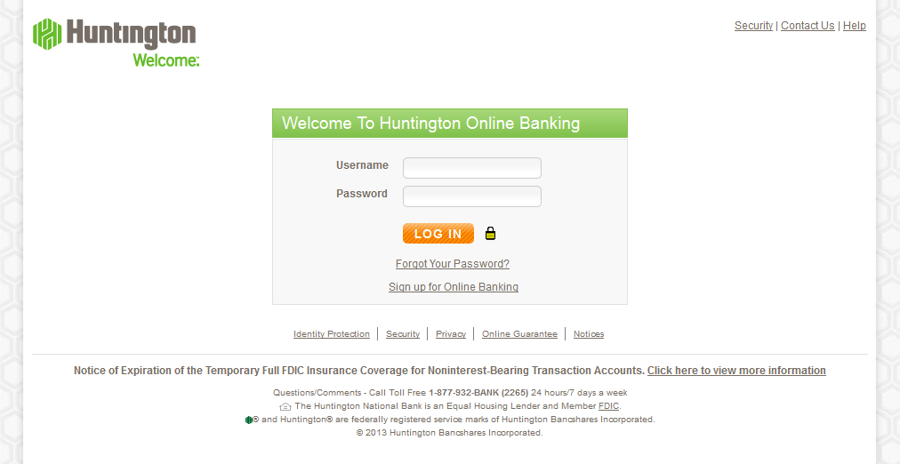

1. Log in to ROL:
   1. **Username**: Enter User ID you created in Step 8.
   2. **Password:** ROL’s password convention for development is **“12341234a”**, without the quotes, as you know…
   3. If you are challenged…
      1. IA (intelligent authentication) in “development” mode is the last word of the challenge. For example:
         1. *“What if your favorite band?”*
         2. Enter “band”.
   4. After successfully being challenged or logged in, you should now see the Accounts Overview page.

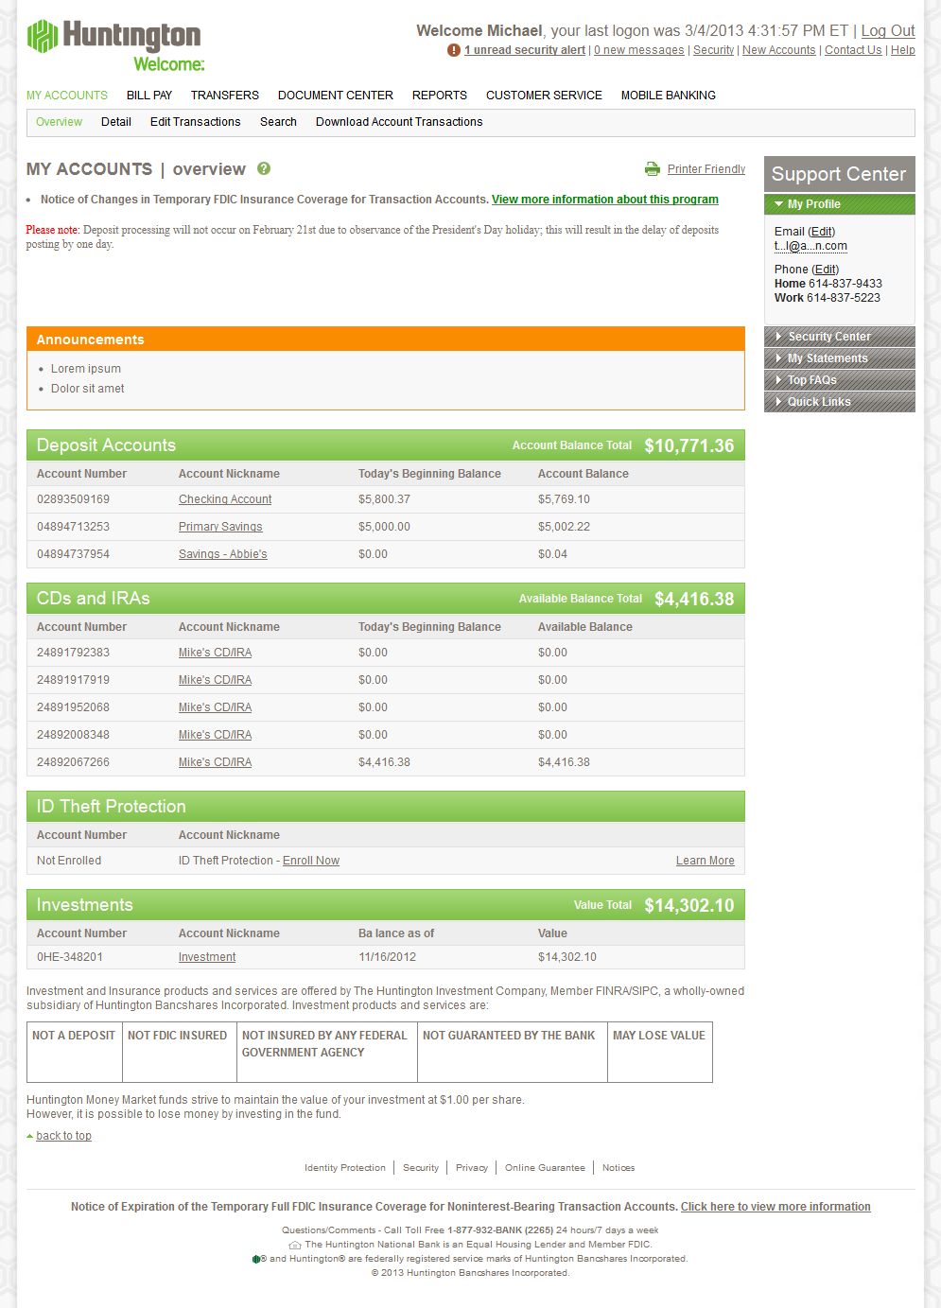

## Notes:

* Tip from Jeremy Simmons: WESB clients log to VoyagerHuntingtonCustom.HNBLog. If you get SSL/TLS errors, try getting the WESB URL from the Web.config and entering it into Firefox. That will allow you to pull the certificate when you add an exception. Then install into the following store when prompted:
  + (check "Show physical stores")trusted root certification authorities -> Local Computer
* ROL relies heavily on Voyager and WESB services. All user names are stored in the mainframe, as opposed to CommonInfo for Business Online. Be careful when you make changes to a user account as it can affect other developers who use it.
* If you get an error when building Business HI saying that a reference to Huntington.OnlineBanking.Business.UI.Models.dll was not found, you will need to build the Business UI before building the Business HI.